Fundamentals of Python Programming
Course-end Project 1

Akansha Chowdhury

Personal Expense Tracker
The Personal Expense Tracker was created based on the give instructions provided and are divided step wise in the below screenshot
Step 1: To Add expenses
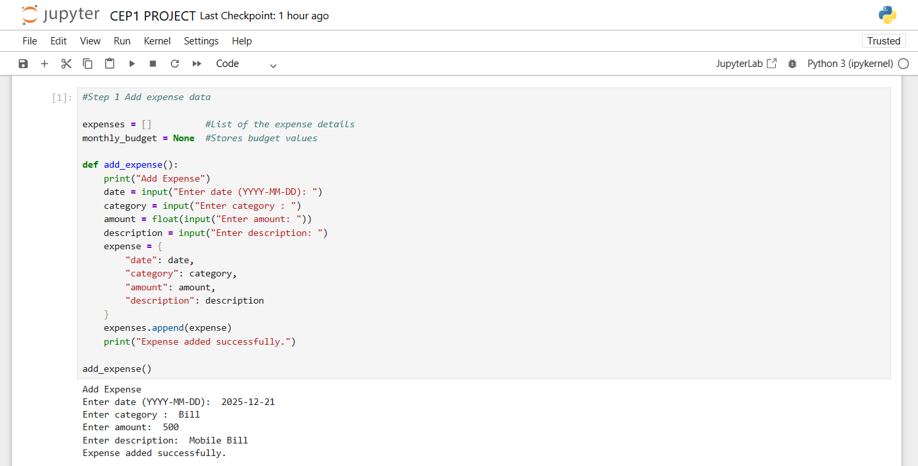
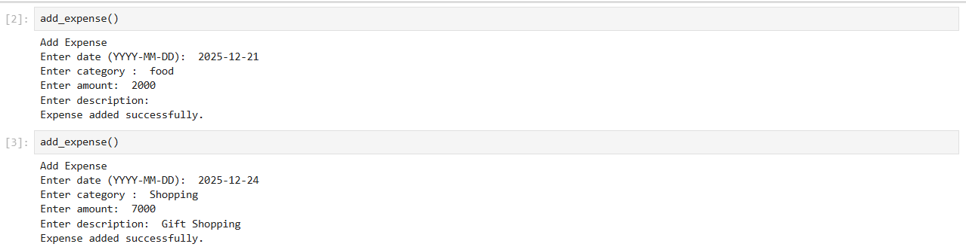
Here in the second entry a blank was left in the description to check whether it can be identified in step 2

Step 2: To view expenses
Here we need to check whether the entries made to the expenses list has any required details (date, category, amount, or description) missing and to skip or notify the user that it is incomplete
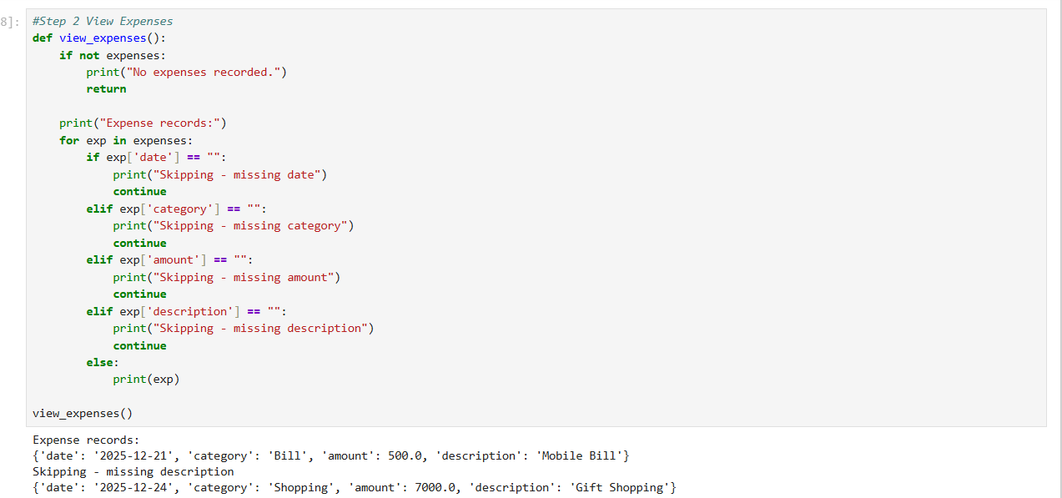
As we can see the second entry in the expense list has been skipping as description is missing there in the second entry.
Step 3: To set monthly budget and track the budget
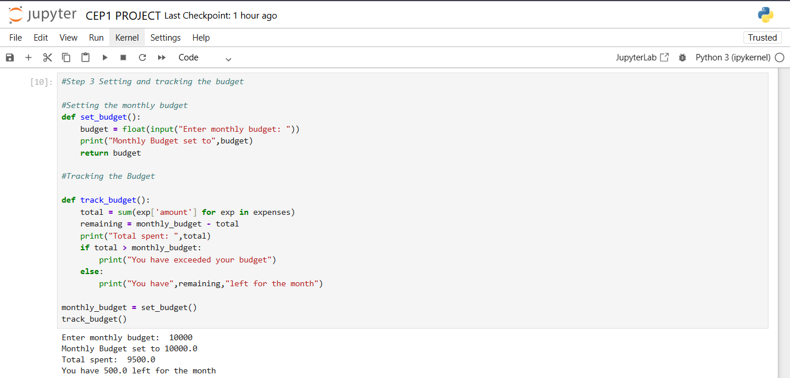

Step 4: To save and load expense
The instructor advises to skip this step as it was not covered in the class
Step 5: To create an interactive menu
